**TITLE:** **IMDb Score Prediction using Data Science**

**PHASE 3: DEVELOPMENT PART 1**

**LOADING AND DATA PREPROCESSING**

**TEAM MEMBER NAME : MONICA HIRIN M**

**NAAN MUTHALVAN ID : au723721243033**



**INTRODUCTION:**

IMDb scores are determined by user ratings and can change over time as more users rate the movie or show.

The problem is to develop a machine learning model to predict the IMDb scores of movies available on Films based on their genre, premiere date, runtime, and language.

This project involves data collection, data prepossessing, feature engineering, clustering algorithms, visualization, and interpretation of results.

The model aims to accurately estimate the popularity of movies to assist users in discovering highly rated films that align with their preferences.

**WORKS DONE IN PREVIOUS PHASES:**

**DEFINITION PHASE:**

Develop a machine learning model to predict the IMDb scores of movies available on Films based on their genre, premiere date, runtime, and language.

**INNOVATION PHASE:**  In this inovation phase of our IMDb score prediction project you can explore advanced techniques and methods to improve the accuracy of prediction.

**PHASE 3:**

**DEVELOPMENT PHASE:**

These phases can be executed using three parts

* Loading and Pre-processing data
* Training and Testing data
* Model testing and Displaying Output

**IMPORTING LIBRARIES:**

We importing the necessary Python libraries, such as

* Pandas for data manipulation
* NumPy for analysis,
* Matplotlib for visualization.

**Loading the dataset:**

* To load data points from a file (e.g., a CSV file), you can use the **pd.read.csv()** function.

Dataset link : https://www.kaggle.com/datasets/luiscorter/netflix-original-films-imdb-scores/

The dataset looks like below,

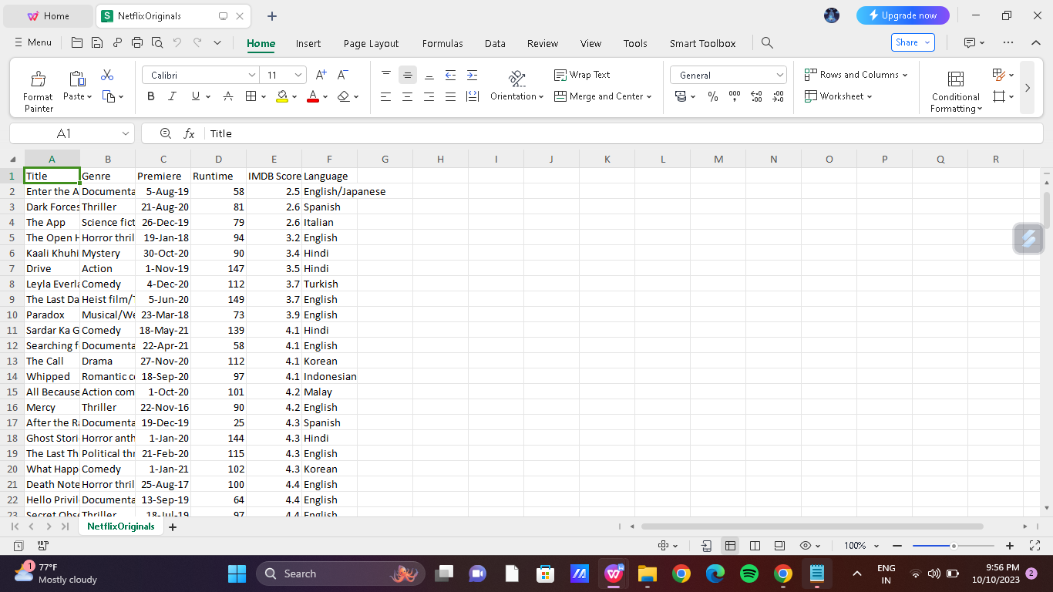

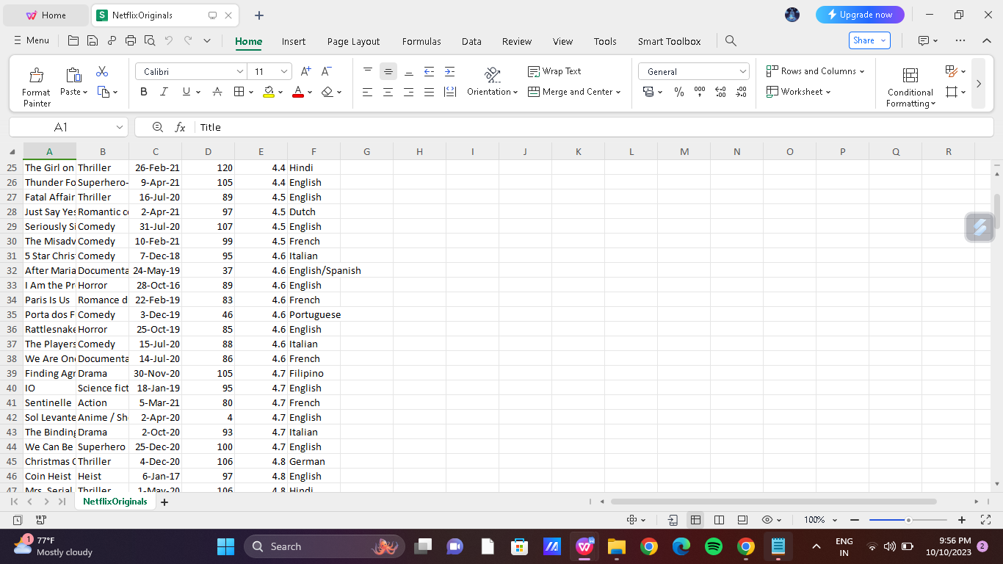

Here’s the code for importing the libraries,

import numpy as np

import pandas as pd

import osfor dirname, _, filenames **in** os.walk('/kaggle/input'):

for filename **in** filenames:

print(os.path.join(dirname, filename))

import matplotlib.pyplot as plt

import seaborn as sns

import plotly.express as pxfrom datetime

import datetime,timedelta

****Dataset****

ds = pd.read_csv("/kaggle/input/netflix-original-films-imdb-scores/NetflixOriginals.csv",encoding = "ISO-8859-1")

ds_date = ds.copy()

ds.head(5)

|  | Title | Genre | Premiere | Runtime | IMDB Score | Language |
| --- | --- | --- | --- | --- | --- | --- |
| 0 | Enter the Anime | Documentary | August 5, 2019 | 58 | 2.5 | English/Japanese |
| 1 | Dark Forces | Thriller | August 21, 2020 | 81 | 2.6 | Spanish |
| 2 | The App | Science fiction/Drama | December 26, 2019 | 79 | 2.6 | Italian |
| 3 | The Open House | Horror thriller | January 19, 2018 | 94 | 3.2 | English |
| 4 | Kaali Khuhi | Mystery | October 30, 2020 | 90 | 3.4 | Hindi |

ds.describe().T

|  | count | mean | std | min | 25% | 50% | 75% | max |
| --- | --- | --- | --- | --- | --- | --- | --- | --- |
| Runtime | 584.0 | 93.577055 | 27.761683 | 4.0 | 86.0 | 97.00 | 108.0 | 209.0 |
| IMDB Score | 584.0 | 6.271747 | 0.979256 | 2.5 | 5.7 | 6.35 | 7.0 | 9.0 |

insights: categorical of IMDB Score 5.7 > rendah 6.35 > sedang 7.0 > tinggi 9.0 > sangat tinggi

<class 'pandas.core.frame.DataFrame'>

RangeIndex: 584 entries, 0 to 583

Data columns (total 6 columns):

# Column Non-Null Count Dtype

--- ------ -------------- -----

0 Title 584 non-null object

1 Genre 584 non-null object

2 Premiere 584 non-null object

3 Runtime 584 non-null int64

4 IMDB Score 584 non-null float64

5 Language 584 non-null object

dtypes: float64(1), int64(1), object(4)

memory usage: 27.5+ KB

ds.isna().sum()

Title 0

Genre 0

Premiere 0

Runtime 0

IMDB Score 0

Language 0

dtype: int64

ds['Title'].value_counts()

Enter the Anime 1

Have a Good Trip: Adventures in Psychedelics 1

Tallulah 1

The Old Guard 1

Tony Robbins: I Am Not Your Guru 1

Cam 1

Earthquake Bird 1

Frankenstein's Monster's Monster, Frankenstein 1

Horse Girl 1

David Attenborough: A Life on Our Planet 1

Name: Title, Length: 584, dtype: int64

ds['Genre'].value_counts()

Documentary 159

Drama 77

Comedy 49

Romantic comedy 39

Thriller 33

...

Romantic comedy-drama 1

Heist film/Thriller 1

Musical/Western/Fantasy 1

Horror anthology 1

Animation/Christmas/Comedy/Adventure 1

Name: Genre, Length: 115, dtype: int64

ds['Premiere'].value_counts()

October 2, 2020 6

November 1, 2019 5

October 18, 2019 5

November 2, 2018 4

June 19, 2020 4

..

September 20, 2019 1

March 10, 2017 1

March 17, 2017 1

May 29, 2015 1

October 4, 2020 1

Name: Premiere, Length: 390, dtype: int64

ds_date["Premiere"] = ds_date["Premiere"].apply(lambda x: "".join(x for x **in** x.replace(".",",")))

ds_date["PremiereDate"] = ds_date["Premiere"].apply(lambda x: datetime.strptime(x, "%B **%d**, %Y").date())

ds_date["Year"] = ds_date["Premiere"].apply(lambda x: "".join(x for x **in** x.replace(",","").split()[-1]))

ds_date["PremiereDate"] = pd.to_datetime(ds_date["PremiereDate"])

ds_date

| Title | Genre | Premiere | Runtime | IMDB Score | Language | PremiereDate | Year |
| --- | --- | --- | --- | --- | --- | --- | --- |
| 0 | Enter the Anime | Documentary | August 5, 2019 | 58 | 2.5 | English/Japanese | 2019-08-05 | 2019 |
| 1 | Dark Forces | Thriller | August 21, 2020 | 81 | 2.6 | Spanish | 2020-08-21 | 2020 |
| 2 | The App | Science fiction/Drama | December 26, 2019 | 79 | 2.6 | Italian | 2019-12-26 | 2019 |
| 3 | The Open House | Horror thriller | January 19, 2018 | 94 | 3.2 | English | 2018-01-19 | 2018 |
| 4 | Kaali Khuhi | Mystery | October 30, 2020 | 90 | 3.4 | Hindi | 2020-10-30 | 2020 |
| ... | ... | ... | ... | ... | ... | ... | ... | ... |
| 579 | Taylor Swift: Reputation Stadium Tour | Concert Film | December 31, 2018 | 125 | 8.4 | English | 2018-12-31 | 2018 |
| 580 | Winter on Fire: Ukraine's Fight for Freedom | Documentary | October 9, 2015 | 91 | 8.4 | English/Ukranian/Russian | 2015-10-09 | 2015 |
| 581 | Springsteen on Broadway | One-man show | December 16, 2018 | 153 | 8.5 | English | 2018-12-16 | 2018 |
| 582 | Emicida: AmarElo - It's All For Yesterday | Documentary | December 8, 2020 | 89 | 8.6 | Portuguese | 2020-12-08 | 2020 |
| 583 | David Attenborough: A Life on Our Planet | Documentary | October 4, 2020 | 83 | 9.0 | English | 2020-10-04 | 2020 |

ds_date.info()

<class 'pandas.core.frame.DataFrame'>

RangeIndex: 584 entries, 0 to 583

Data columns (total 8 columns):

# Column Non-Null Count Dtype

--- ------ -------------- -----

0 Title 584 non-null object

1 Genre 584 non-null object

2 Premiere 584 non-null object

3 Runtime 584 non-null int64

4 IMDB Score 584 non-null float64

5 Language 584 non-null object

6 PremiereDate 584 non-null datetime64[ns]

7 Year 584 non-null object

dtypes: datetime64[ns](1), float64(1), int64(1), object(5)

memory usage: 36.6+ KB

ds['Language'].value_counts()

English 401

Hindi 33

Spanish 31

French 20

Italian 14

Portuguese 12

Indonesian 9

Japanese 6

Korean 6

German 5

Turkish 5

English/Spanish 5

Polish 3

Dutch 3

Marathi 3

English/Hindi 2

Thai 2

English/Mandarin 2

English/Japanese 2

Filipino 2

English/Russian 1

Bengali 1

English/Arabic 1

English/Korean 1

Spanish/English 1

Tamil 1

English/Akan 1

Khmer/English/French 1

Swedish 1

Georgian 1

Thia/English 1

English/Taiwanese/Mandarin 1

English/Swedish 1

Spanish/Catalan 1

Spanish/Basque 1

Norwegian 1

Malay 1

English/Ukranian/Russian 1

Name: Language, dtype: int64

ds['Genre'].value_counts()genre = ds['Genre'].value_counts()genre.head()

Documentary 159

Drama 77

Comedy 49

Romantic comedy 39

Thriller 33

Name: Genre, dtype: int64

plt.figure(figsize=(16, 5))ds['Genre'].value_counts().head(10).plot(kind='bar', color='red')plt.xlabel('Genre')plt.ylabel('Number of Genre')plt.xticks(rotation=90)plt.show(block=True)

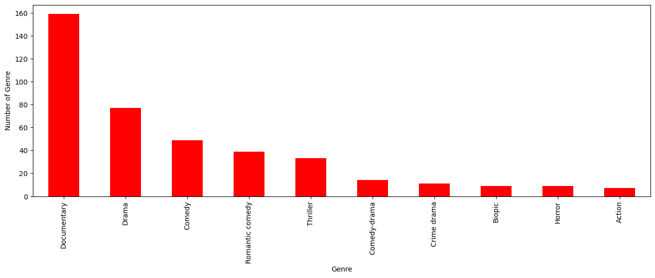

ds[['Genre', 'IMDB Score']].sort_values('IMDB Score', ascending=False).drop_duplicates('Genre').head(10).plot(x='Genre', y='IMDB Score', kind='bar', color='red')

plt.xlabel('Genre')

plt.ylabel('IMDB Score')

plt.show(block=True)

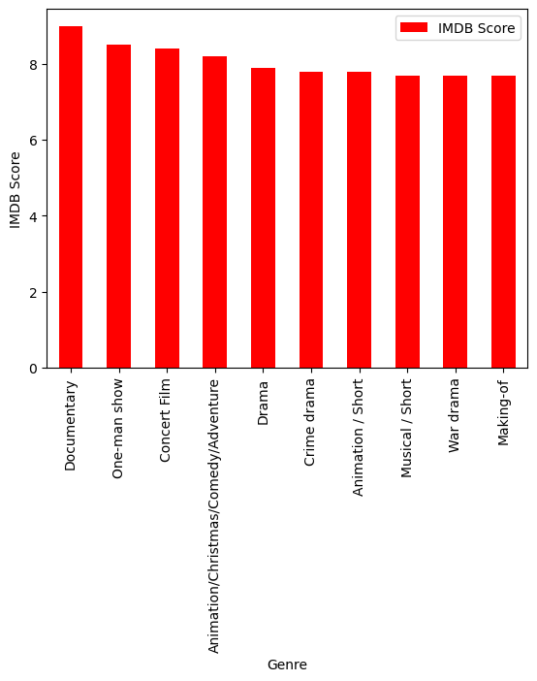

ds['Language'].value_counts()

English 401

Hindi 33

Spanish 31

French 20

Italian 14

Portuguese 12

Indonesian 9

Japanese 6

Korean 6

German 5

Turkish 5

English/Spanish 5

Polish 3

Dutch 3

Marathi 3

English/Hindi 2

Thai 2

English/Mandarin 2

English/Japanese 2

Filipino 2

English/Russian 1

Bengali 1

English/Arabic 1

English/Korean 1

Spanish/English 1

Tamil 1

English/Akan 1

Khmer/English/French 1

Swedish 1

Georgian 1

Thia/English 1

English/Taiwanese/Mandarin 1

English/Swedish 1

Spanish/Catalan 1

Spanish/Basque 1

Norwegian 1

Malay 1

English/Ukranian/Russian 1

Name: Language, dtype: int64

ds_lang = ds['Language'].value_counts()

ds_lang.head(5).plot(kind='bar', color='red')

plt.xlabel('Languge')

plt.ylabel('Number of Language')

plt.show(block=True)

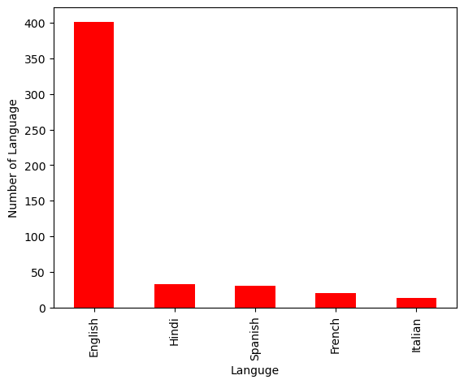ds.groupby('Language').agg({'Runtime': 'sum'}).sort_values('Runtime', ascending=False).head(5).plot(kind='bar',color='red')

plt.xlabel('Language')

plt.ylabel('Runtime')

plt.show(block=True)

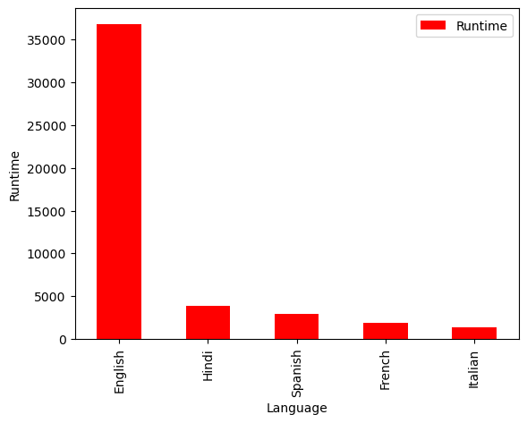

ds_english = ds[ds['Language'] == 'English'].sort_values('IMDB Score', ascending=False)ds_english.head()

| Title | Genre | Premiere | Runtime | IMDB Score | Language |
| --- | --- | --- | --- | --- | --- |
| 583 | David Attenborough: A Life on Our Planet | Documentary | October 4, 2020 | 83 | 9.0 | English |
| 581 | Springsteen on Broadway | One-man show | December 16, 2018 | 153 | 8.5 | English |
| 579 | Taylor Swift: Reputation Stadium Tour | Concert Film | December 31, 2018 | 125 | 8.4 | English |
| 578 | Ben Platt: Live from Radio City Music Hall | Concert Film | May 20, 2020 | 85 | 8.4 | English |
| 577 | Dancing with the Birds | Documentary | October 23, 2019 | 51 | 8.3 | English |

sns.barplot(y=ds_english['Genre'].head(10), x=ds_english['IMDB Score'], color='red')plt.show(block=True)

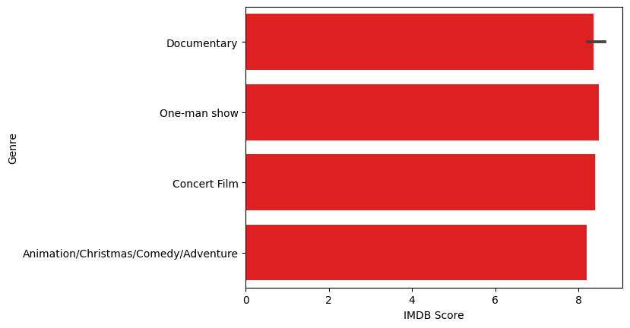

ds_movie = ds[['Title', 'IMDB Score']].sort_values('IMDB Score', ascending=False).head(10)

sns.barplot(y='Title', x='IMDB Score', data=ds_movie, color='red')

plt.show(block=True)

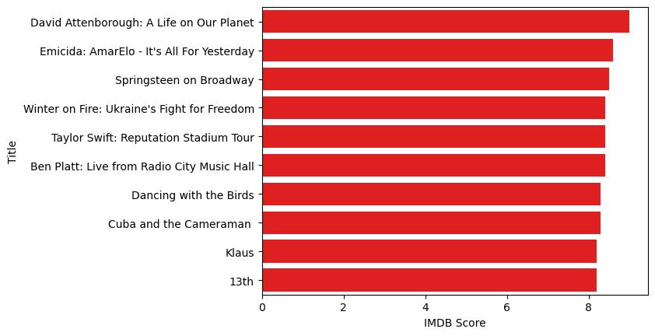

ds[['Title', 'Runtime']].sort_values('Runtime', ascending=False).head(10).plot(x='Title', y='Runtime', kind='bar', color='red')

plt.xlabel('Movie Title')

plt.ylabel('Runtime')

plt.show(block=True)

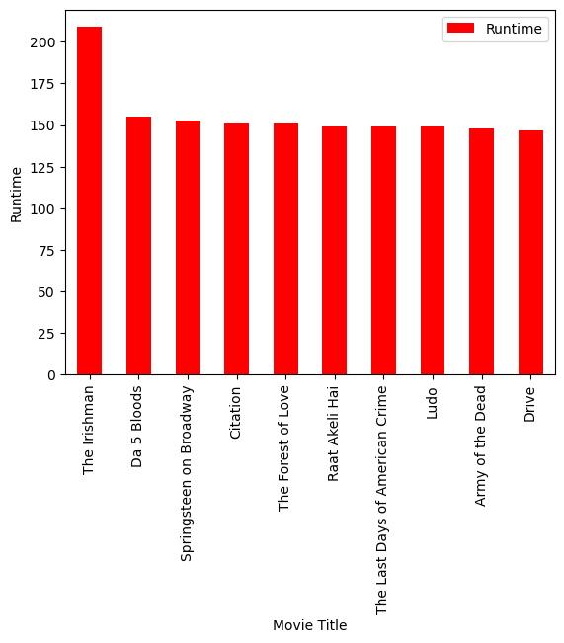

ds_date.groupby('Year').agg({'Runtime': 'sum'}).sort_values('Runtime', ascending=False).plot(kind='bar', color='red')

plt.xlabel('Year')

plt.ylabel('Sum of Runtime')

plt.show(block=True)

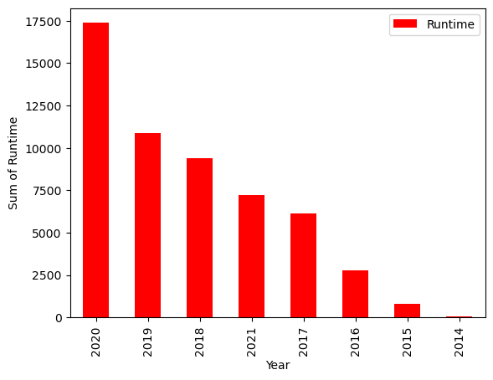

ds_date.groupby('Year').agg({'Title': 'count'}).sort_values('Title', ascending=False).plot(kind='bar', color='red'

)plt.xlabel('Year')

plt.ylabel('Number of Film')

plt.show(block=True)

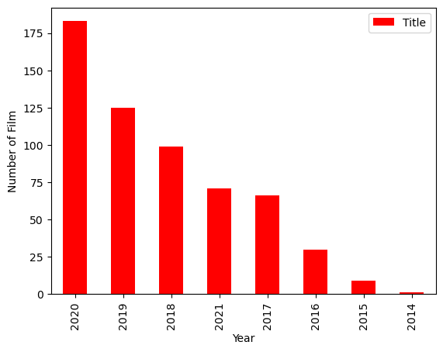

**Conclusion :**

In conclusion, predicting IMDb scores is a complex task that involves various factors and challenges.IMDb scores are influenced by a multitude of subjective and contextual factors, and no model can perfectly capture all of these nuances.

To improve IMDb score predictions, it's crucial to consider factors such as user reviews, genre, director, actors, and release date, among others. However, it's essential to remember that IMDb scores are ultimately a reflection of audience opinions, and these opinions can change over time. Therefore, any prediction model should be periodically updated and validated against new data.